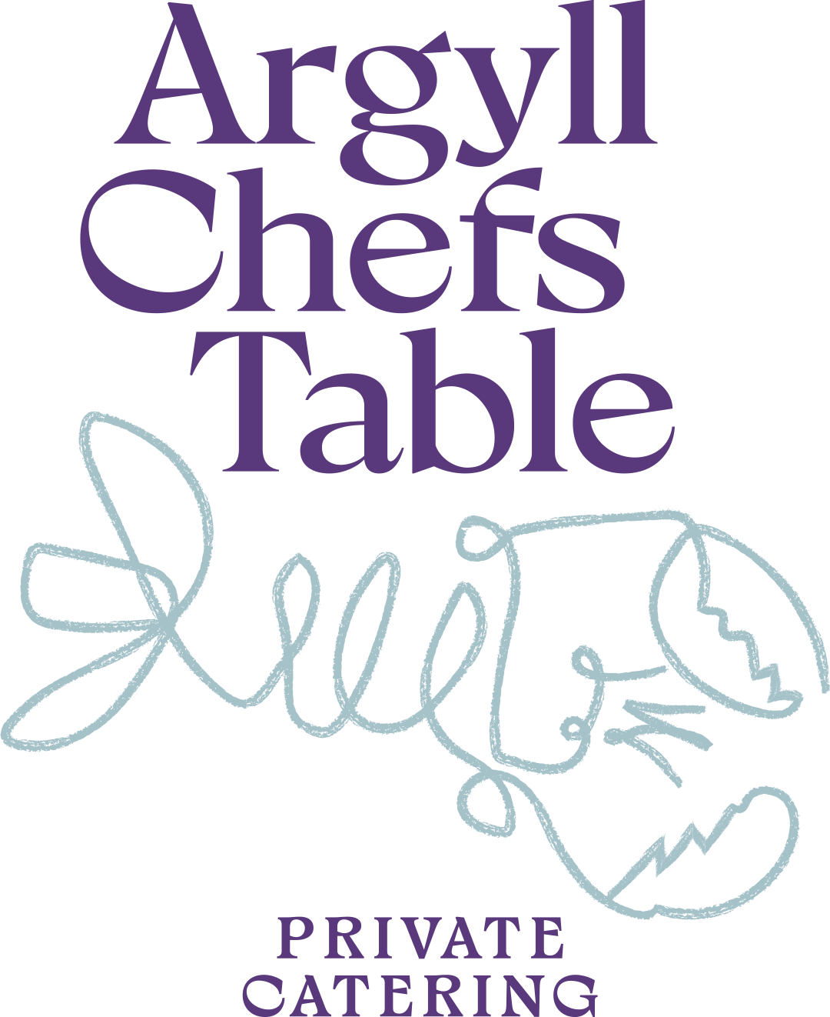

SMALL PLATES · FAMILY SHARING
Choose 1 bread · 1 dip · 3 vegetable · 2 fish · 1 meat · 1 dessert
Additional courses may be added on request.
BREAD
Foccaccia with Rosemary & Garlic
Milk Bread · Garlic Butter
Poolish Bread · Chive Smoked Butter
Fresh Soda Bread & Salted Butter
DIPS
Za’aloouk
Coriander Hummus
Black Olive & Caper Tapenade

VEGETABLES
Chard & Cauliflower Salad · Pistachio Pesto · Raisins
Smashed Roasted Potatoes · Garden Chimichurri
Grilled Courgettes · Mint Labneh · Pine Nuts · Sherry Vinegar Peppers
Blue Cheese Salad · Roasted Pear · Walnuts · Chicory · Apple
Salt-Baked Beetroot · Crème Fraîche, Apple, Walnut Dressing
Heritage Tomatoes · Cantabrian Anchovy · Sweet Peppers · Extra Virgin Olive Oil
Fresh Handmade Torteloni, Request your filling!
Goat’s Cheese · Roasted Carrot · Harissa · Preserved Lemon
FISH
Seabass · Ponzu · Chilli · Spring Onion
Baked Loch Creran Oysters · Crème Fraîche · Parmesan · Dill Oil
Roast Loch Melfort Sea Trout Lemon Butter Sauce
Plancha Scallops · ’Nduja Butter
Crab Salad · Lime Leaf · Fennel · Spinach · Crème Fraîche

MEAT
Wild Argyll Venison · Muhammara Dressing
Picanha of Beef · Salsa Rossa
Highland Lamb Rump · Salsa Verde · Olives
Crispy Pork Belly · Soy & Honey Caramel · Spring Onions
Grilled Dukkah Chicken · Romesco Sauce

DESSERT
Dark Chocolate Mousse · Meringue · Mint Ice Cream
Whisky Crème Brûlée · Raspberry Sorbet · Shortbread
Buttermilk Panna Cotta · Strawberry Consommé · Mint · Salted Almond Crumble
Traditional Scottish Cranachan · Honey · Raspberry · Chantilly · Oats
Salted Caramel Tart · Espresso Ice Cream

