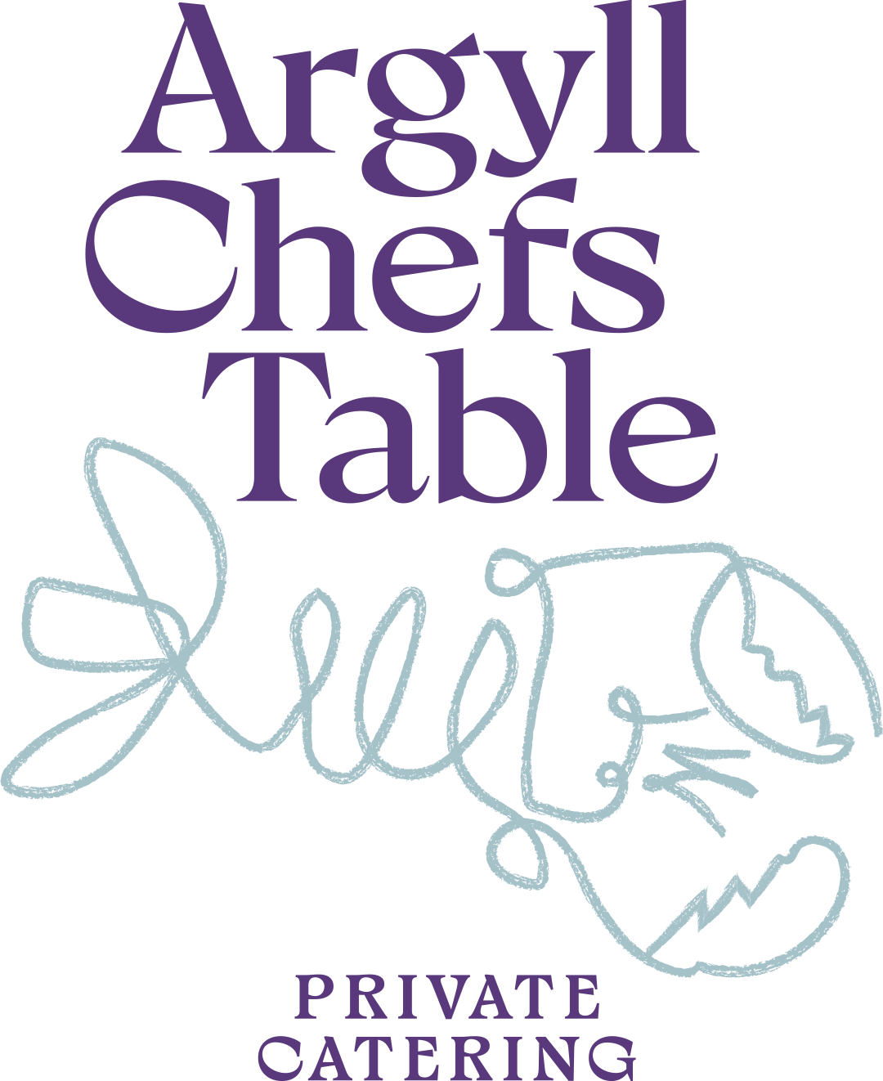

Sample Menu Land & Sea

SOFT MILK BREAD
Malt Whisky Butter

HAND-DIVED ISLE OF MULL SCALLOP
Shetland Mussels · Celeriac · Seaweed Butter

CURED LOCH MELLORT SEATROUT
Apple · Buttermilk · Fennel · Dill

WILD ARGYLL VENISON
Pickled Beets · Crispy Potato · Arran Mustard Jus

ISLE OF MULL CHEDDAR

BUTTERMILK PANNA COTTA
Salted Apple Crumble · Strawberry, Szechuan Meringue

