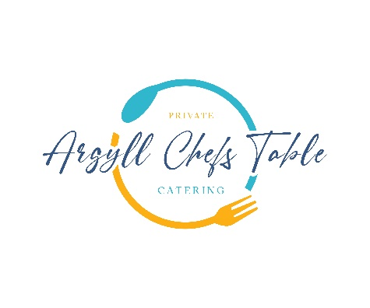

Land & Sea

Wine Pairing Optional

Freshly Baked Focaccia Confit Garlic, Rosemary, Dulse Sea Salt

–

Platter of Loch Creran Oysters Mignonette, Lemon

-

Hand Dived Isle of Mull Scallops, Ardern Black Pudding

-

Cured Loch Seatrout, with Crème Fraiche, Dill Emulsion, Herbs

-

Wild Argyll Venison , Garden Chimichurri

-

Dark Chocolate Mousse

Highland Whisky Ice Cream, Meringue, Scottish Berry’s