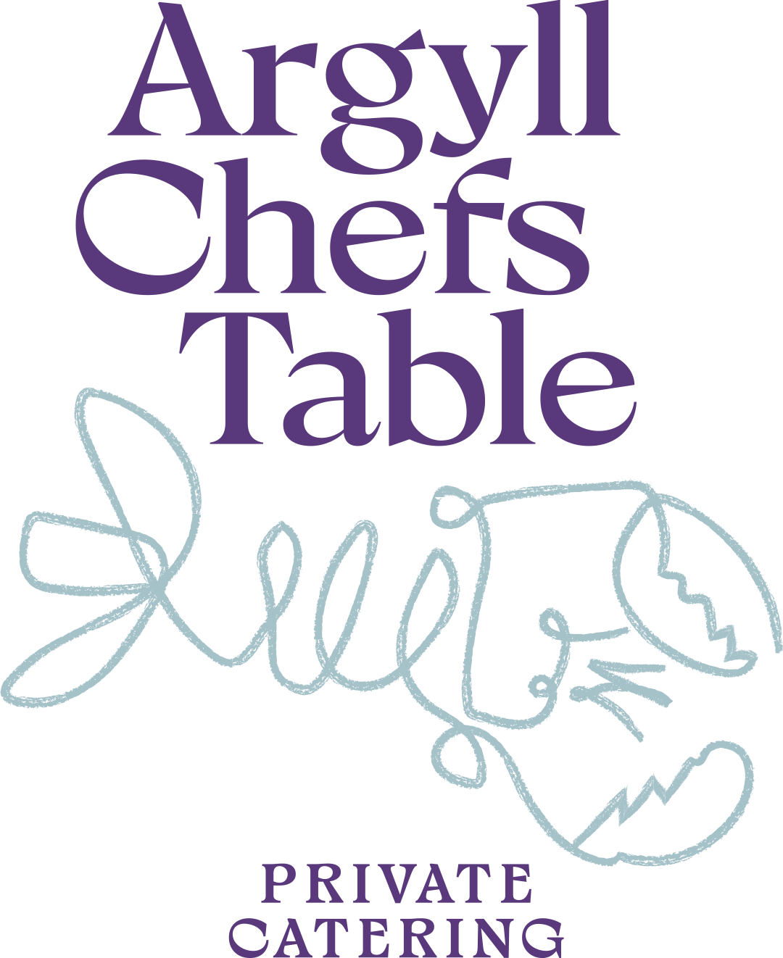
Sample Menu

Soft Milk Bread
Garlic Butter

HAND-DIVED ISLE OF MULL SCALLOP
Guancialie, Pea, Dill

ASPARAGUS AGNOLOTTI
Ricotta · Isle of Mull Cheddar · Truffle Butter

SCOTTISH HIGHLAND LAMB
Dukka Granola · Beef fat Carrot · Sheep’s Cheese

DARK CHOCOLATE MOUSSE
Pedro Ximénez · Prunes · Goats’ Milk Sorbet · Hazelnut Crisp

