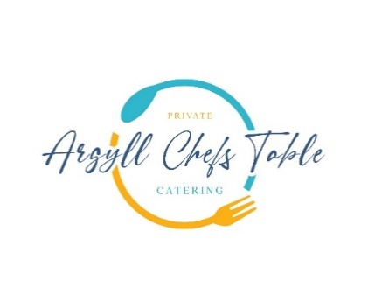

Loch Creran Oyster Lemon & Shallot Dressing

Freshly Baked Bread with Leek Butter & Blackthorn Sea Salt

Ilse of Mull Scallops

Ardfern Black Pudding, Apple, Peas & Dill

Wild Argyll Venison

Pressed Potato, Heritage Carrot, Haggis, Arran Mustard Jus

Scottish Cranachan

Raspberry’s, Malt Whisky, Oats, Cream, Local Honey