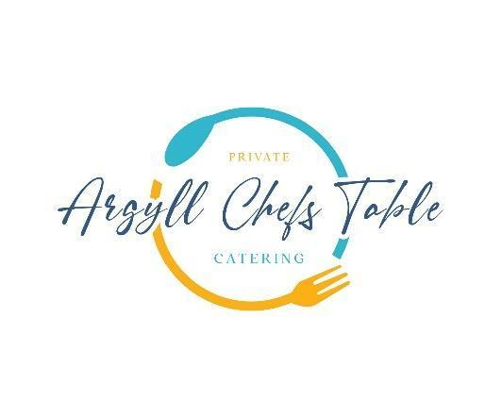

**Kilmartin Castle**

**Family Sharing For 10 Guests or more**

**Freshly Baked Focaccia with Rosemary, Confit Garlic, Extra Virgin Olive Oil, Baked Scottish Goats Cheese & Roasted Tomato Sauce**

**Wild Argyll Venison Carpaccio**

**Garden Chimichurri, Wild Berry’s**

**Skillet Isle of Mull King Scallops**

**Garlic & Chilli Butter**

**Baked Loch Melfort Trout**

**Lemon & Parsley Sauce**

**Roasted Squash, Chilli, Pumpkin Seeds, Feta, Dill**

**Smashed Baby Potatoes & Romesco**

**Baked Leeks, Puy Lentils, Fresh Hers, Creme Fraiche**

**Dessert**

**Buttermilk Pannacotta,Strawberry Sorbet, Cardamom Crumble, Basil**