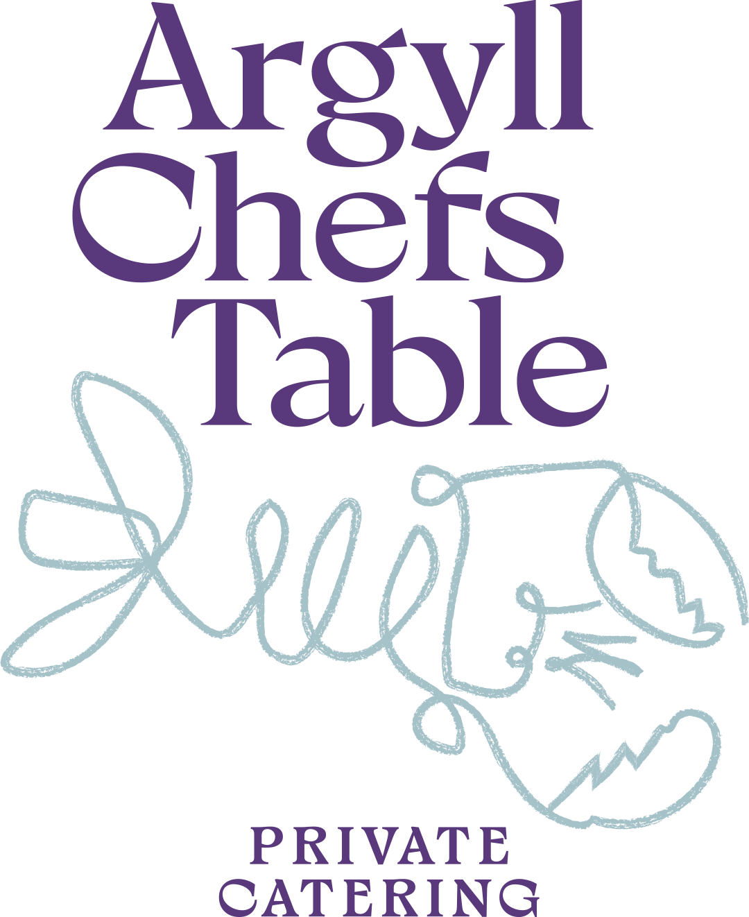

Canapes

VENISON TARTARE
Capers, shallots, crisp sourdough
MINI HAGGIS, NEEPS & TATTIES
Whisky cream
RARE ROAST BEEF
Horseradish cream, crostini
CHICKEN LIVER PARFAIT
Brioche, onion marmalade
CRISPY PORK BELLY
Apple purée, crackling
SMOKED DUCK BREAST
Cherry gel, toasted oatcake

FISH / SEAFOOD
LOCH CRERAN OYSTER
Shallot vinaigrette
ISLE OF MULL SCALLOP
Cauliflower purée, crispy pancetta
SMOKED SALMON BLINI
Crème fraîche, dill
SHETLAND COD FRITTER
Tartare emulsion
WEST COAST CRAB
Lemon mayo, baby gem
CURED TROUT
Pickled cucumber, rye crisp

VEGETARIAN
GOATS CHEESE TARTLET
Caramelised onion, thyme
WILD MUSHROOM ARANCINI
Truffle emulsion
ROASTED BEETROOT
Whipped crowdie, candied walnut
HERITAGE TOMATO
Basil, aged balsamic
kCARAMELISED SHALLOT TARTE TATIN
Crème fraîche
PARMESAN GOUGÈRE
Light choux pastry, warm cheese filling

